1. Turn right onto Rt.16 as you exit the main gate. After driving past AEON, move onto the GREEN colored lane.

2. Drive up the ramp onto **HONCHO-YAMANAKA,** Keep left at the 1st Y-split following the signs for **YOKOHAMA-YOKOSUKA** **(Yoko-Yoko)** Toll Road.

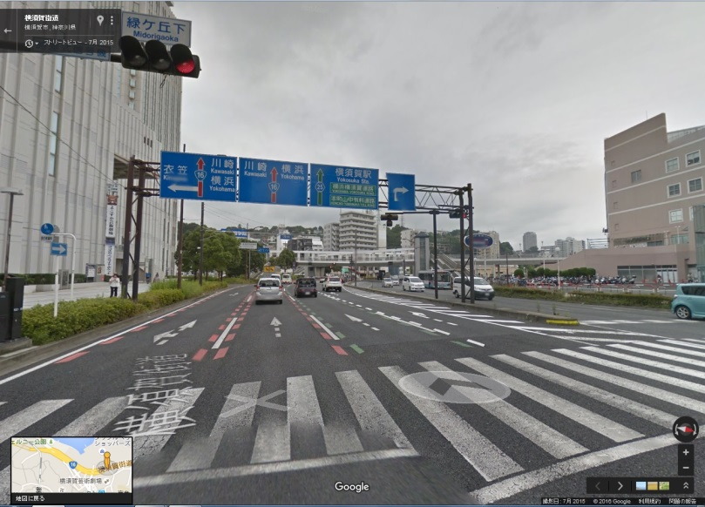 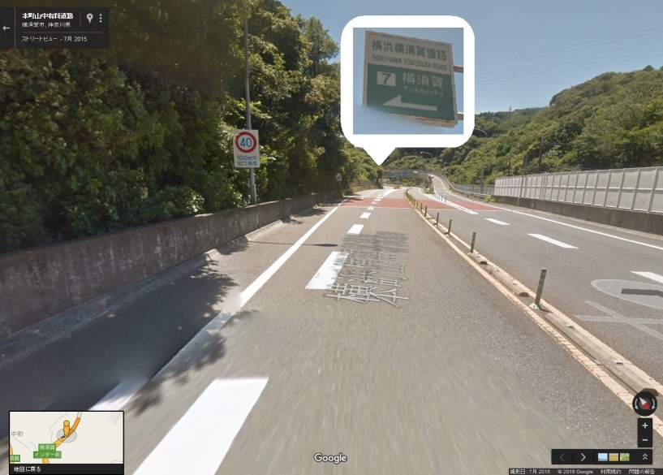

**COASKA**

4.Continue straight on Yoko-Yoko Rd, heading toward HACHIOJI(**19km).** Pay 740yen at the Kariba toll gate.

3. Take a ticket at the next toll gate, keep right at the 2nd Y-split following the signs for **YOKOHAMA.**

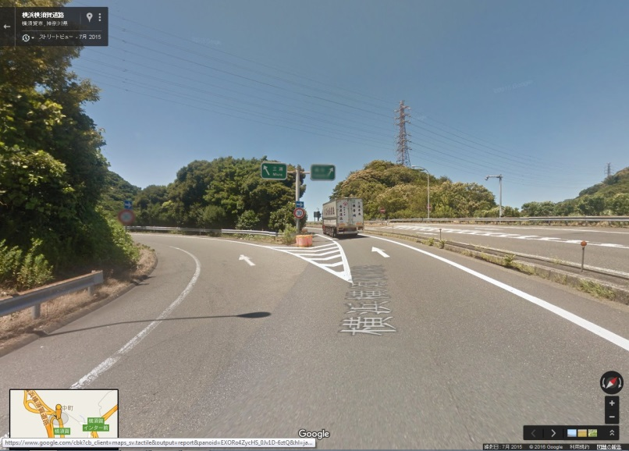 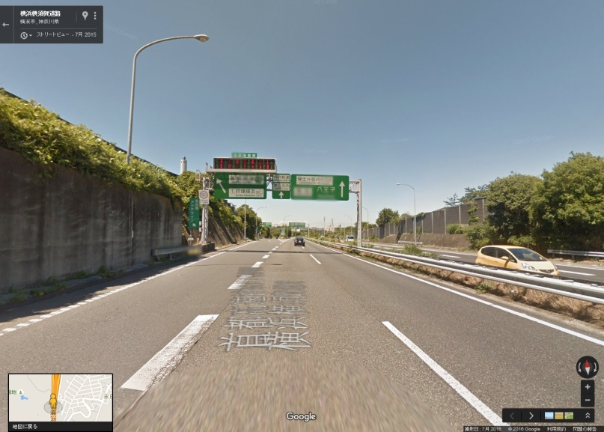

**保土ヶ谷バイパス**

**HODOGAYA BY-PASS**

**八王子**

**HACHIOUJI**

**横浜**

**YOKOHAMA**

6. Move into the leftmost lane. Keep left lane at 3rd Y-split and follow the signs for **SHIMOKAWAI/SEYA.**

5. After the toll gate, continue straight on **HODOGAYA BY-PASS** for about **9km.**

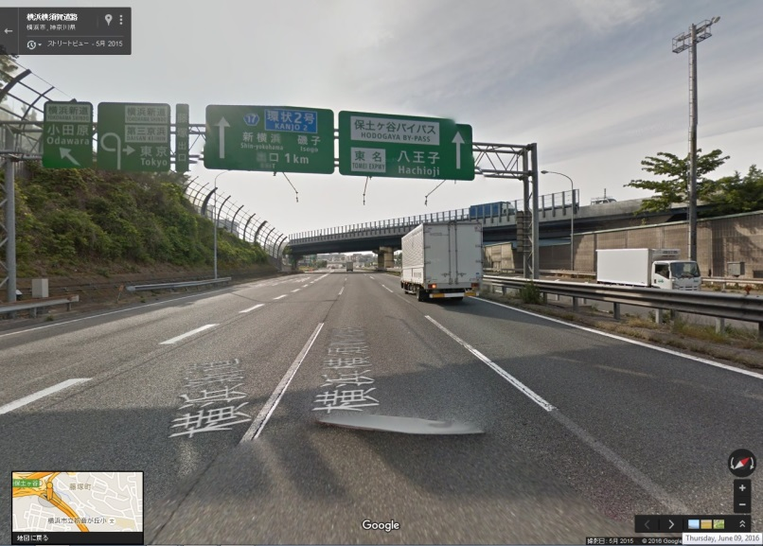 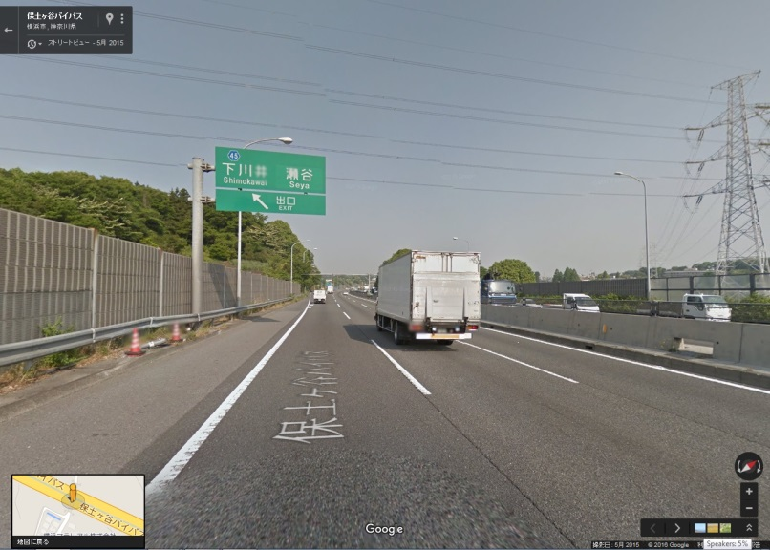

**下川井　　　　　瀬谷**

**SHIMOKAWAI　　SEYA**

7. Turn RIGHT onto Rt.45, then keep straight on Rt.45 for about **5.5km**.

8. Keep straight merging onto Rt.140.

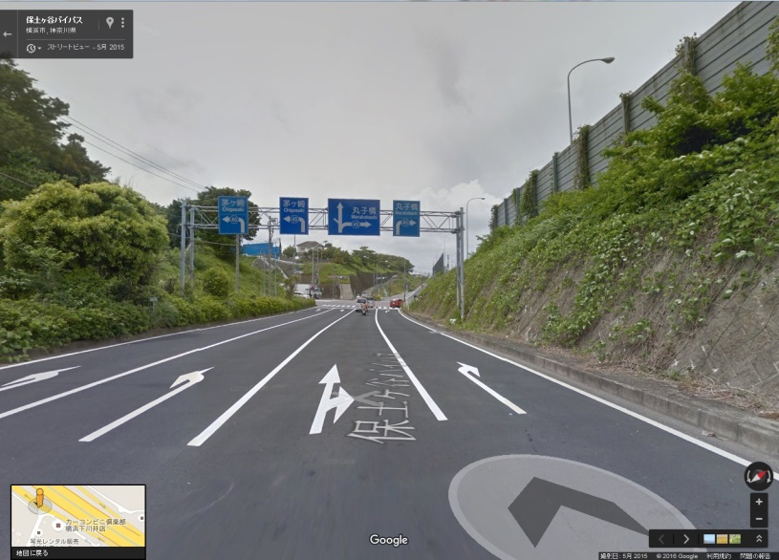 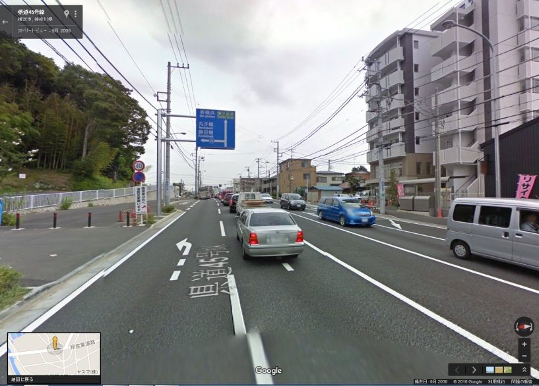

10. Turn left at **UMEDABASHI** intersection.

9. After driving past LALA PORT,

move into the leftmost lane.

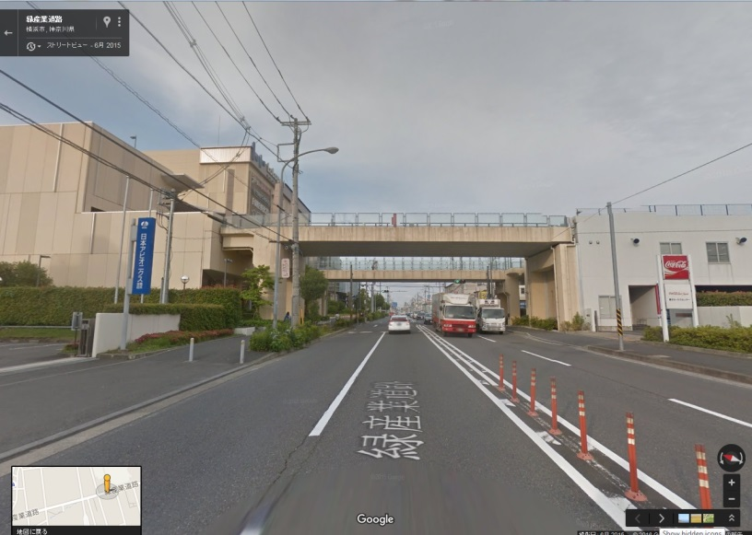 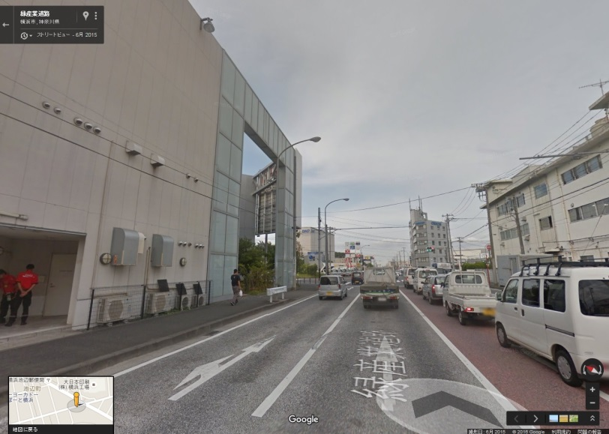

**Umedabashi Intersection**

**LALA PORT**

11. LTO entrance is located on the right-hand side just across AUTOBACS after passing the 1st traffic light where **UNYUSHIKYOKU MAE** is only for exit.

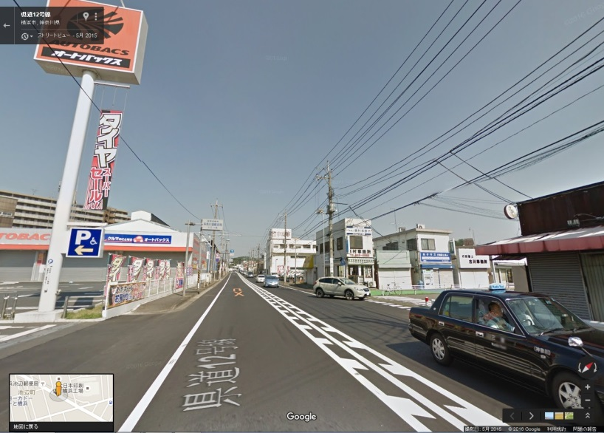

**YOKOHAMA LTO**　　　　　　　　　 **(KANAGAWA UNYU SHIKYOKU 神奈川運輸支局)**

Address: 3540 Ikonobe, Tsuzuki, Yokohama 　　　Phone #: 050-5540-2035 (Extension 037)

**HOUR OF OPERATION** MON – FRI 08:45 – 11:30 13:00 – 15:30 CLOSED: SAT, SUN, and JAPANESE HOLIDAY